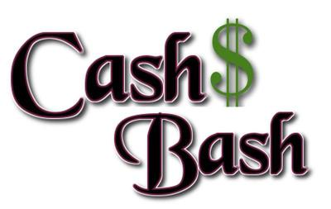
Wednesday October 30th 6pm
CASH BASH FOR MEMBERS 6PM
RSVP today at 517-265-2142
Special Menu created by Chef Toni
Come for a chance to win CASH
Dress up for Halloween for an entry in a special drawing!

