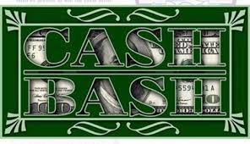Cash Bash

December 11th 6pm

Drawing at 7pm

Delicious Menu created by Chef Toni

RSVP today by calling 517-265-2142

