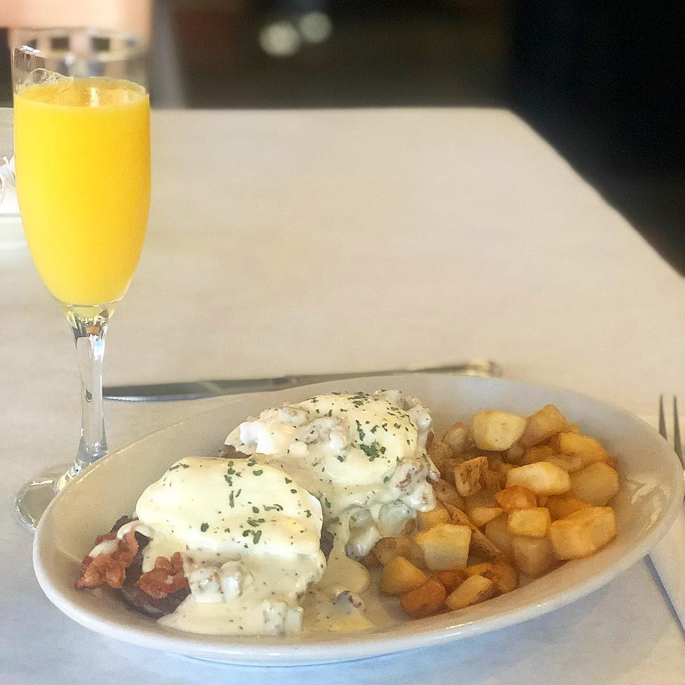
Join us for Sunday Brunch
November 10th 10am-2pm
The Hills of Lenawee
Bring the Family
Delicious Menu Created by Chef Toni
Mimosas and Bloody Mary’s
RSVP today at 517-265-2142

